Model 1

Training set: 10:1:1 (83 epochs = 40 hours)

Val Class Images Labels P R mAP 0.5 mAP 0.5 : 0.95

all 300 3600 0.993 0.997 0.993 0.825

mcp2 300 300 0.993 0.997 0.992 0.825

pip2 300 300 0.997 1 0.995 0.834

dip2 300 300 0.993 0.997 0.994 0.843

mcp3 300 300 0.987 0.99 0.989 0.821

pip3 300 300 0.993 0.997 0.995 0.838

dip3 300 300 0.993 0.997 0.994 0.838

mcp4 300 300 0.993 0.997 0.994 0.824

pip4 300 300 0.987 0.99 0.986 0.805

dip4 300 300 0.993 0.997 0.994 0.823

mcp5 300 300 0.997 1 0.995 0.817

pip5 300 300 0.995 1 0.995 0.815

dip5 300 300 0.997 1 0.995 0.8

Test Class Images Labels P R mAP 0.5 mAP 0.5 : 0.95

all 300 3600 0.999 0.999 0.995 0.831

mcp2 300 300 1 1 0.995 0.844

pip2 300 300 0.997 0.997 0.995 0.834

dip2 300 300 1 1 0.995 0.833

mcp3 300 300 1 1 0.995 0.833

pip3 300 300 1 1 0.995 0.834

dip3 300 300 1 1 0.995 0.84

mcp4 300 300 0.999 1 0.995 0.824

pip4 300 300 0.996 0.997 0.995 0.823

dip4 300 300 1 1 0.995 0.831

mcp5 300 300 0.999 1 0.995 0.795

pip5 300 300 0.999 1 0.995 0.833

dip5 300 300 1 1 0.995 0.842

Model 2

Training set: 7:1.5:1.5 + image_size: 640 -> 320 ( 120 epochs = 12 hours)

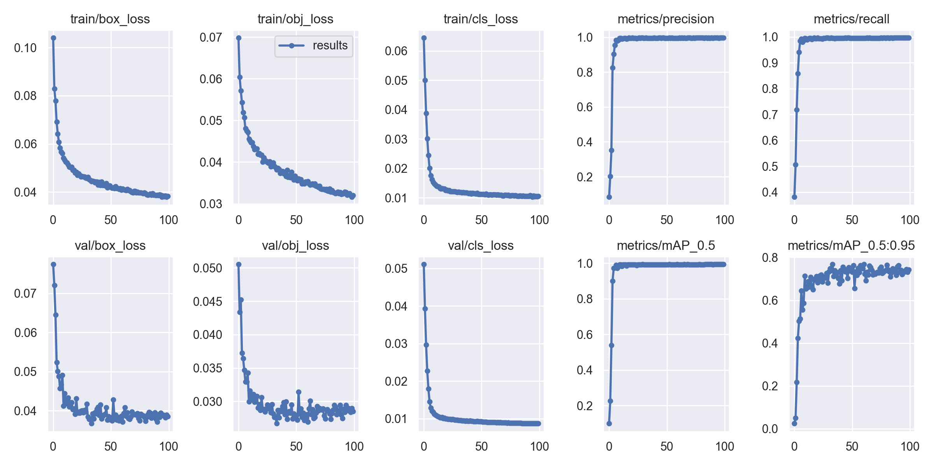

Val Class Images Labels P R mAP@.5 mAP@.5:.95:

all 564 6768 0.995 0.995 0.992 0.768

mcp2 564 564 0.996 0.996 0.992 0.771

pip2 564 564 0.996 0.996 0.992 0.784

dip2 564 564 0.995 0.993 0.993 0.768

mcp3 564 564 0.996 0.996 0.992 0.765

pip3 564 564 0.996 0.996 0.994 0.79

dip3 564 564 0.995 0.995 0.992 0.769

mcp4 564 564 0.996 0.996 0.992 0.762

pip4 564 564 0.994 0.995 0.991 0.769

dip4 564 564 0.994 0.995 0.992 0.761

mcp5 564 564 0.996 0.996 0.991 0.756

pip5 564 564 0.994 0.995 0.99 0.76

dip5 564 564 0.995 0.994 0.991 0.76

Test Class Images Labels P R mAP@.5 [mAP@.5:.95](mailto:mAP@.5:.95)

all 475 5700 0.994 0.994 0.993 0.857

mcp2 475 475 0.996 0.996 0.994 0.838

pip2 475 475 0.996 0.996 0.994 0.869

dip2 475 475 0.996 0.996 0.995 0.863

mcp3 475 475 0.994 0.994 0.992 0.836

pip3 475 475 0.996 0.996 0.995 0.872

dip3 475 475 0.993 0.994 0.991 0.866

mcp4 475 475 0.989 0.989 0.989 0.844

pip4 475 475 0.995 0.996 0.992 0.86

dip4 475 475 0.996 0.996 0.995 0.874

mcp5 475 475 0.994 0.992 0.994 0.837

pip5 475 475 0.991 0.992 0.994 0.863

dip5 475 475 0.996 0.996 0.994 0.865

Wrong label: yolov5-master\My data\wrong label

9670760_v06 9025933_v06

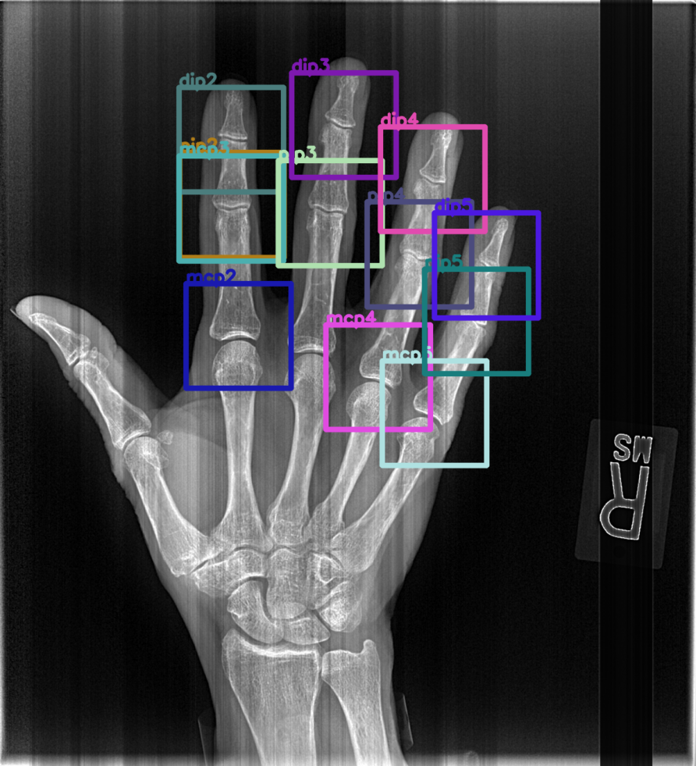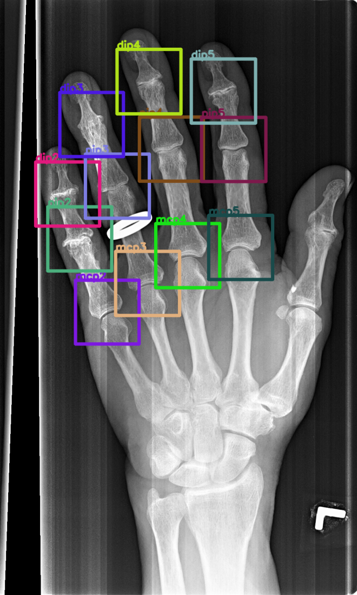

9658663_v06 9014883_v06

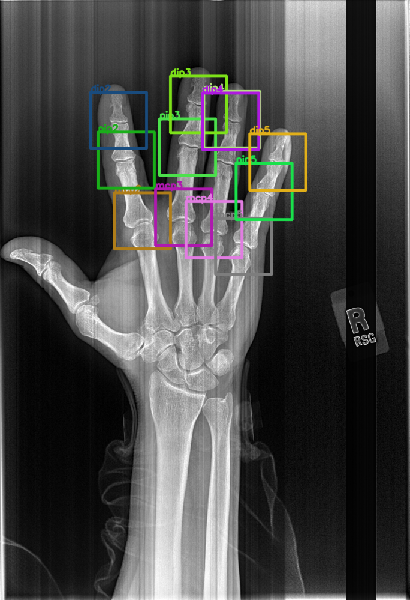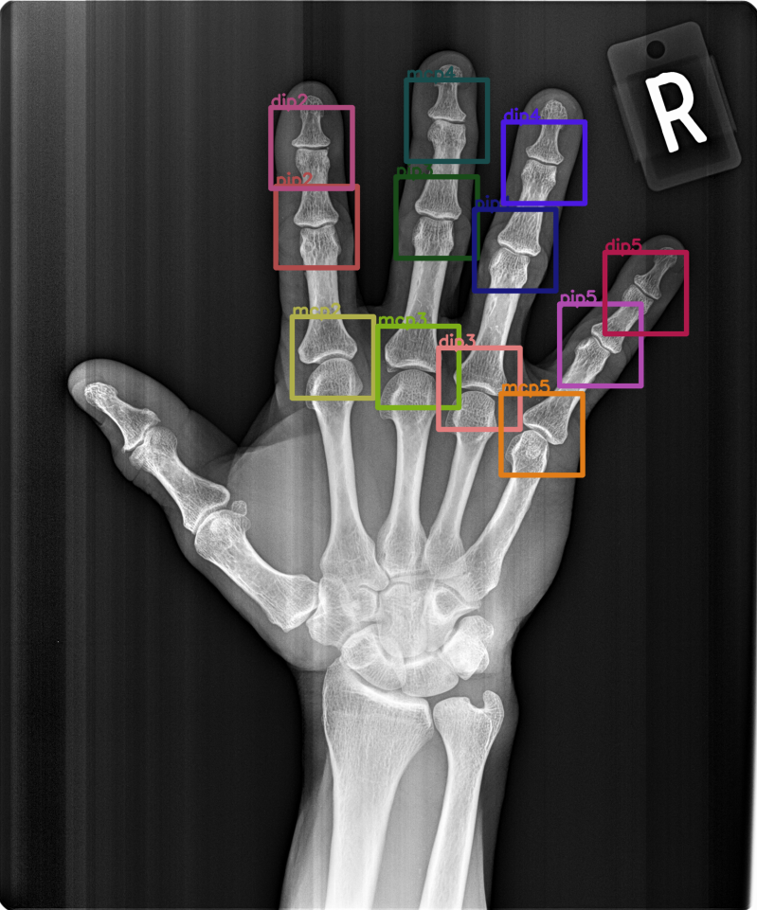

9063934_v06

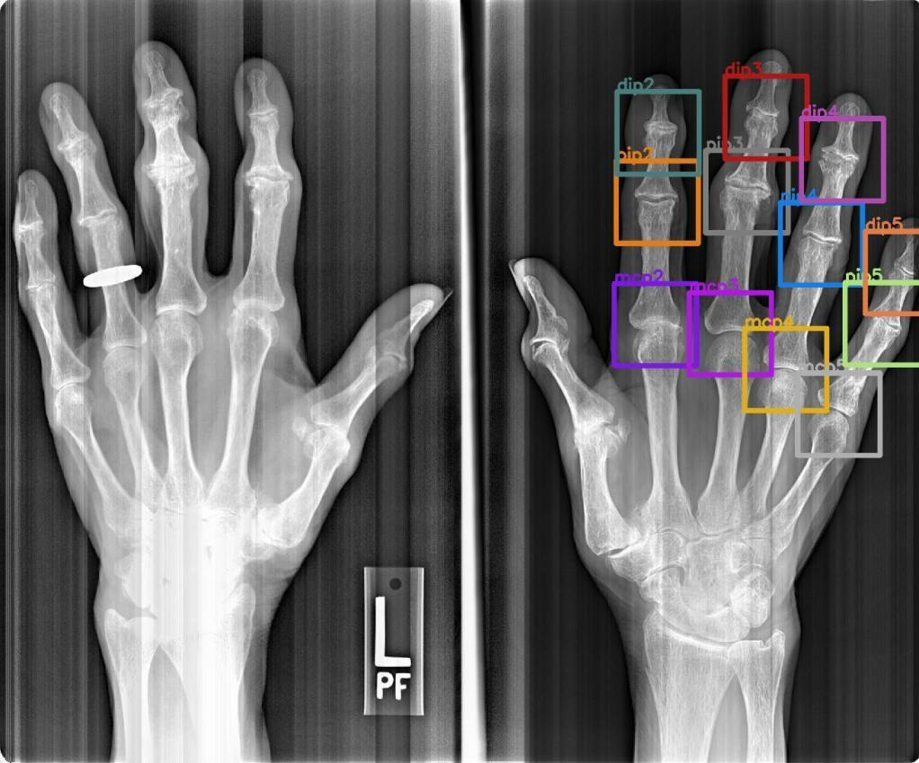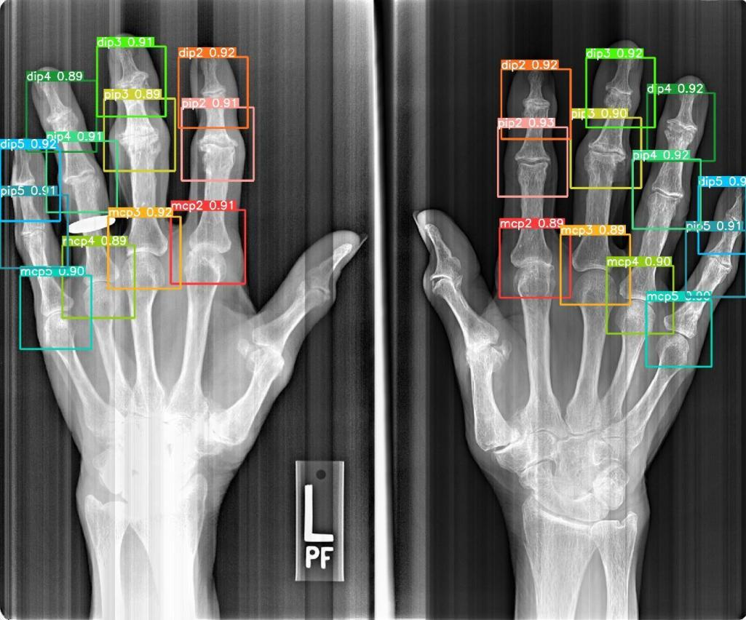

Wrong Detection for Model 2

9479978 (Val) 9217512 (Test) 9850845 (Test)

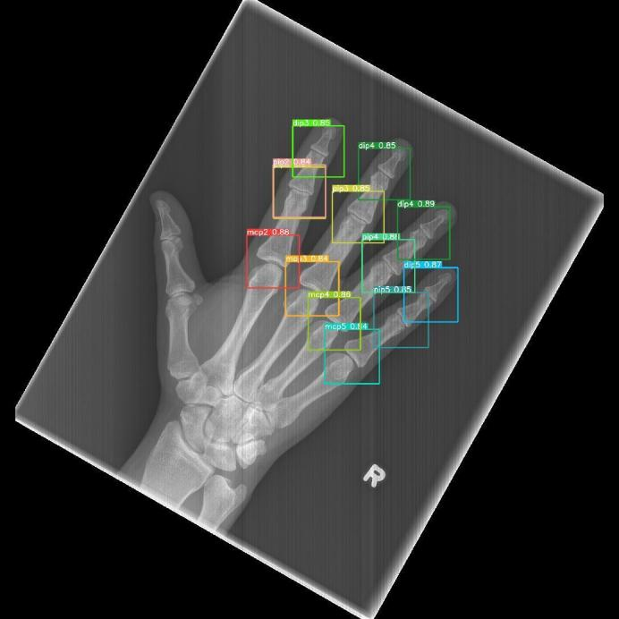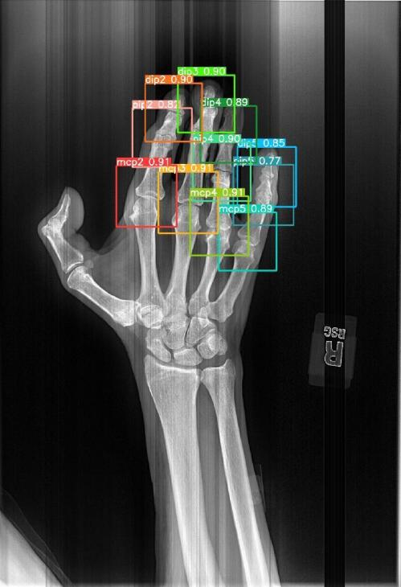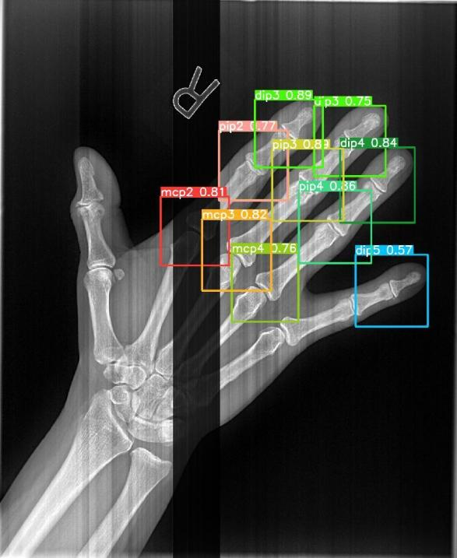

9264200 (Test) 9621716 (Train)

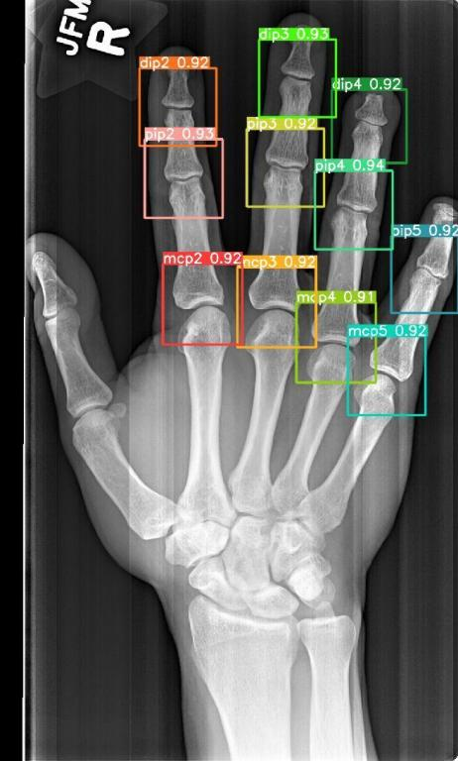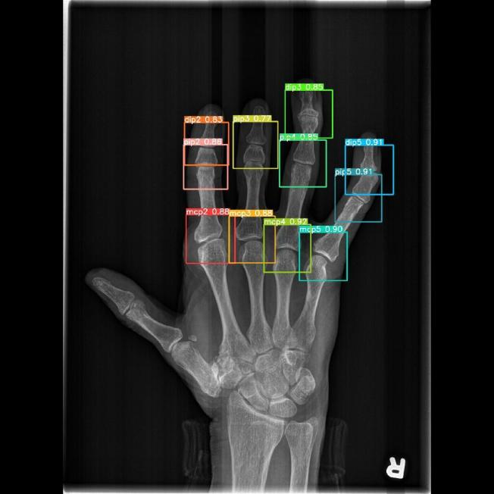

Model 3

After cleaning the wrong label

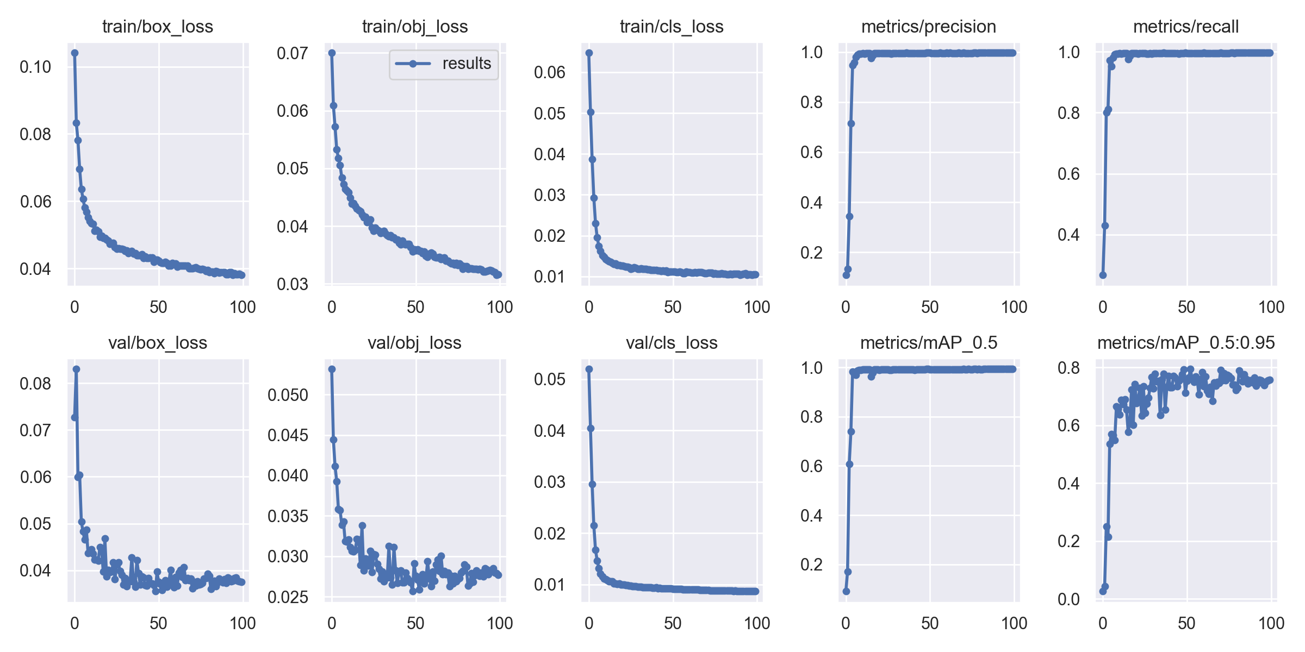

Test

Class Images Labels P R mAP@.5 [mAP@.5:.95](mailto:mAP@.5:.95)

all 468 5616 1 1 0.995 0.802

mcp2 468 468 1 1 0.995 0.791

pip2 468 468 1 1 0.995 0.814

dip2 468 468 1 1 0.995 0.809

mcp3 468 468 1 1 0.995 0.787

pip3 468 468 0.999 0.998 0.995 0.816

dip3 468 468 1 0.999 0.995 0.806

mcp4 468 468 1 1 0.995 0.804

pip4 468 468 1 1 0.995 0.801

dip4 468 468 0.999 1 0.995 0.812

mcp5 468 468 1 1 0.995 0.798

pip5 468 468 1 1 0.995 0.789

dip5 468 468 0.999 1 0.995 0.803

Val

Class Images Labels P R mAP@.5 mAP@.5:.95

all 562 6744 0.995 0.995 0.992 0.795

mcp2 562 562 0.996 0.996 0.993 0.783

pip2 562 562 0.995 0.995 0.991 0.804

dip2 562 562 0.995 0.993 0.992 0.803

mcp3 562 562 0.996 0.996 0.992 0.782

pip3 562 562 0.995 0.995 0.993 0.813

dip3 562 562 0.994 0.993 0.991 0.804

mcp4 562 562 0.996 0.995 0.993 0.792

pip4 562 562 0.994 0.995 0.992 0.793

dip4 562 562 0.994 0.995 0.992 0.806

mcp5 562 562 0.995 0.995 0.992 0.783

pip5 562 562 0.994 0.995 0.992 0.787

dip5 562 562 0.994 0.995 0.99 0.788

Distance Visualization (in the pixel scale) detection: red ground truth: blue

1 5

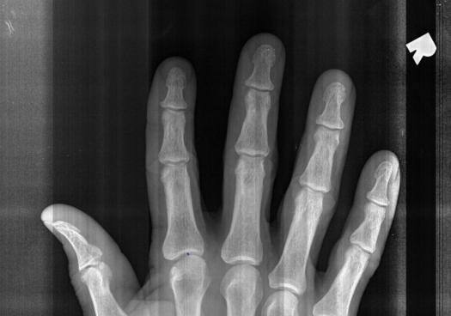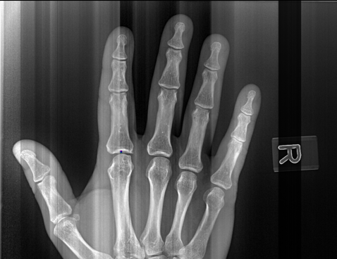

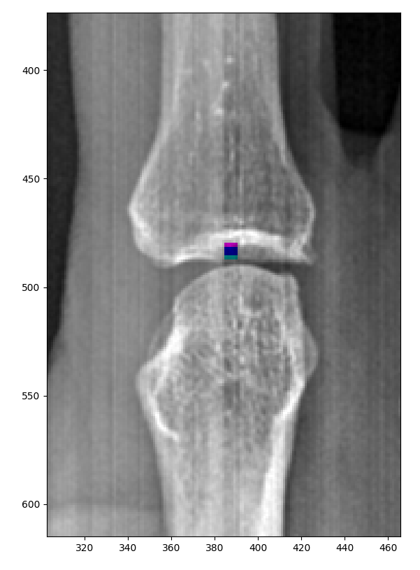

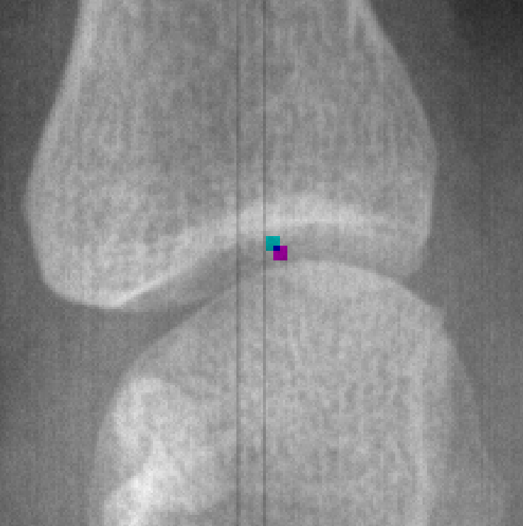

9815657 9851573

10 15 20

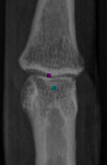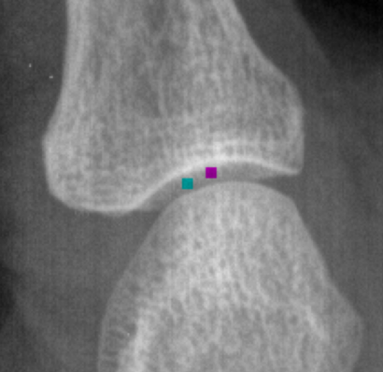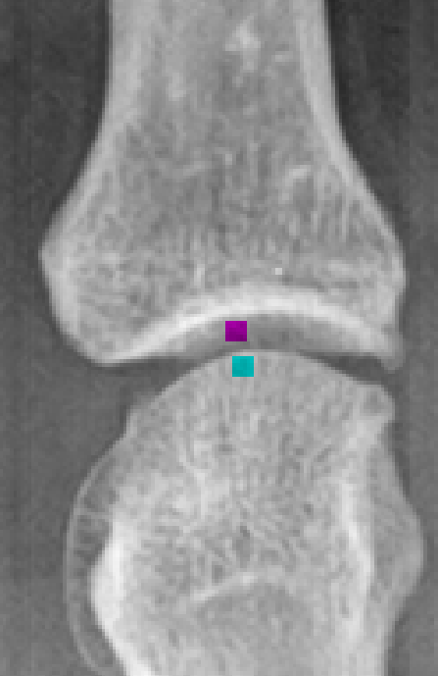

9567504 9820479 9217997

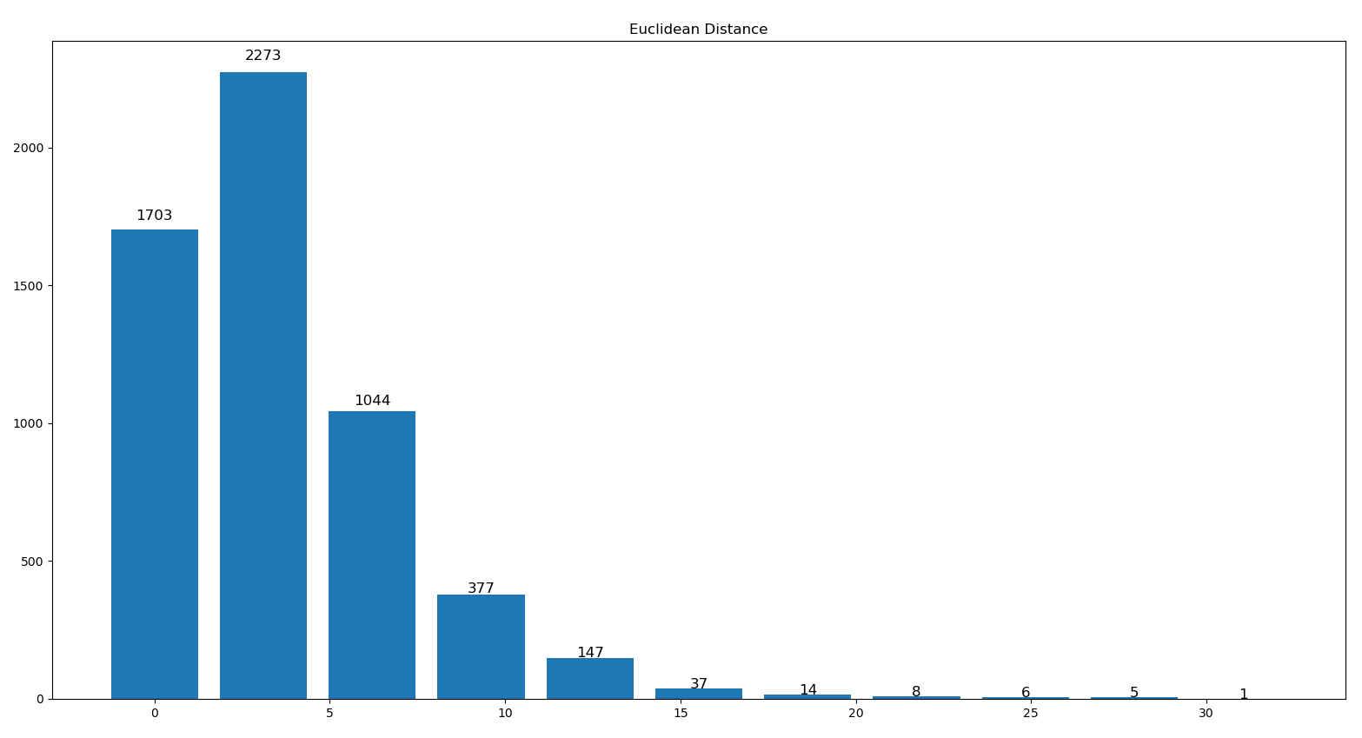Euclidean Distance Histogram

Angle Error

|  |  |  |  |  |  |  |  |  |  |  |  |
| --- | --- | --- | --- | --- | --- | --- | --- | --- | --- | --- | --- |
| mcp2 | pip2 | dip2 | mcp3 | pip3 | dip3 | mcp4 | pip4 | dip4 | mcp5 | pip5 | dip5 |
| 0.102 | 0.086 | 0.100 | 0.091 | 0.081 | 0.112 | 0.163 | 0.134 | 0.170 | 0.235 | 0.208 | 0.247 |

Overall: 0.144

Visualization:

0.05 0.1 0.2 0.35 0.7

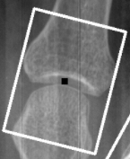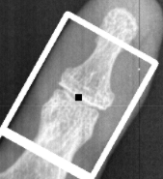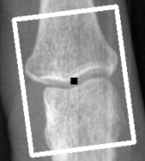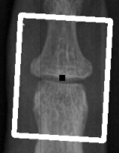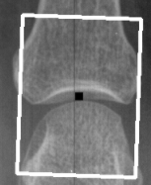

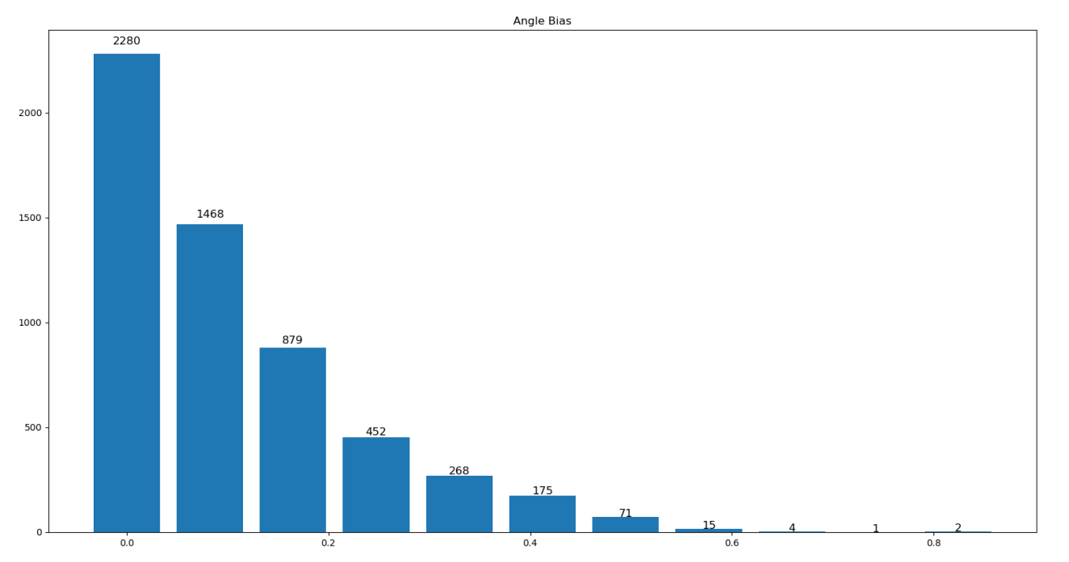

Fingertips detection

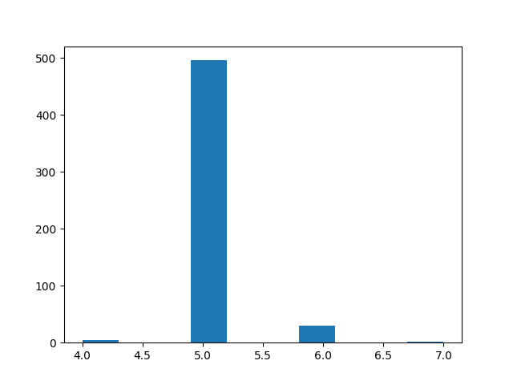

Overall mAP

Prediction: joint detection + angle estimate (connect joint center but not fingertips)

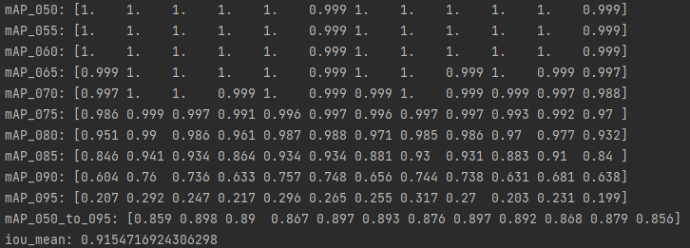

9008322_v06

YOLO

Detect

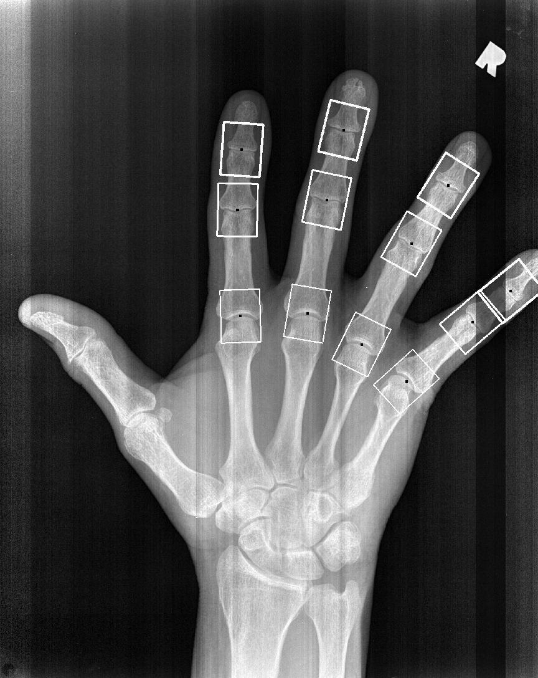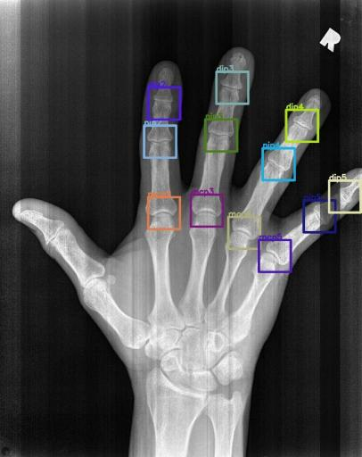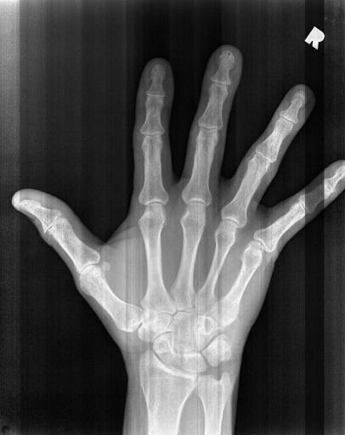

Rotate

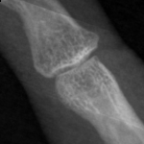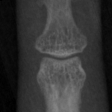

Oringinal X-Ray Image

Image with detection box

Image with rotated box

Crops from detection box

Crops from rotated box